Create an ORCID ID
Creating an ORCID ID is simple. You can create it at orcid.org, or you can create it directly in Pure. If you create it directly in Pure, your Pure-profile and your ORCID ID will be linked together automatically.
In order to create an ORCID ID in Pure, you must log on to the Pure of your institution, and follow these steps:
Click to Edit profile: 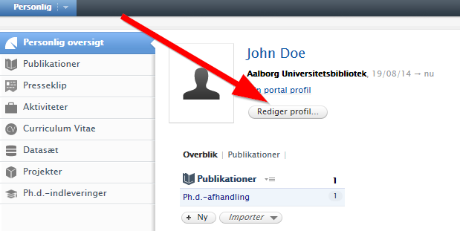

- In the following window, you click on Create ORCID ID: 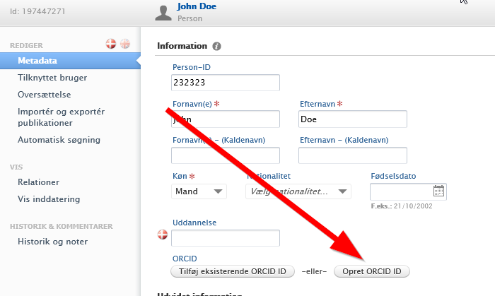
- In the next window, you add your email address (unless it is already there) and click on Create: 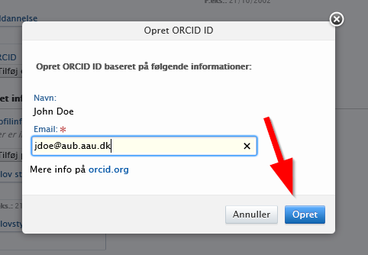

- Now, you have an ORCID ID. However, it has yet to be linked to your Pure-profile. This takes place automatically when you click on Save: 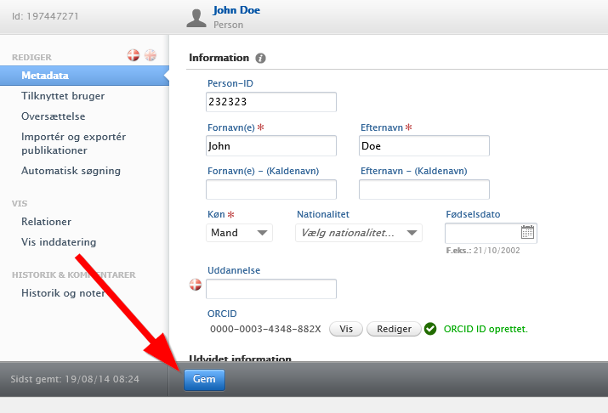

- Once you return to the Pure start page, your ORCID ID will be visible below your name. You now have an ORCID ID that is linked to your Pure-profile: 