How to link existing ORCID ID with Pure
If you already have an ORCID ID, you can quite easily link it to your Pure-profile and thus benefit from the advantages of re-using information.
Begin by logging on to Pure. Then click on Edit profile: 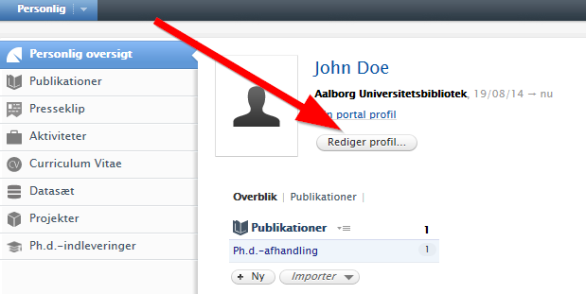

- Click on Add existing ORCID ID: 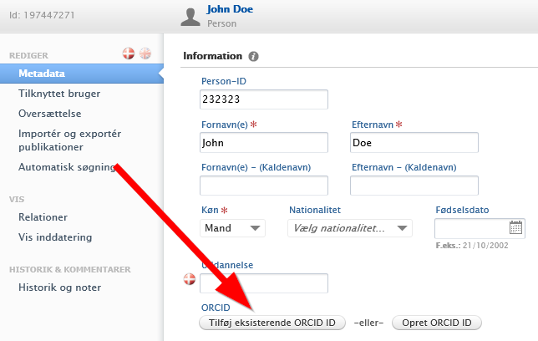

- A dialogue box will appear in which you must enter your ORCID ID. You may want to check at orcid.org whether you got it right. Once you have entered your ORCID ID, please click on Add: 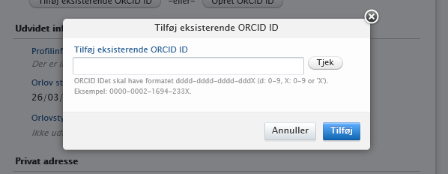

- Remember to click Save, to make sure that your ORCID ID automatically links to your Pure-profile. 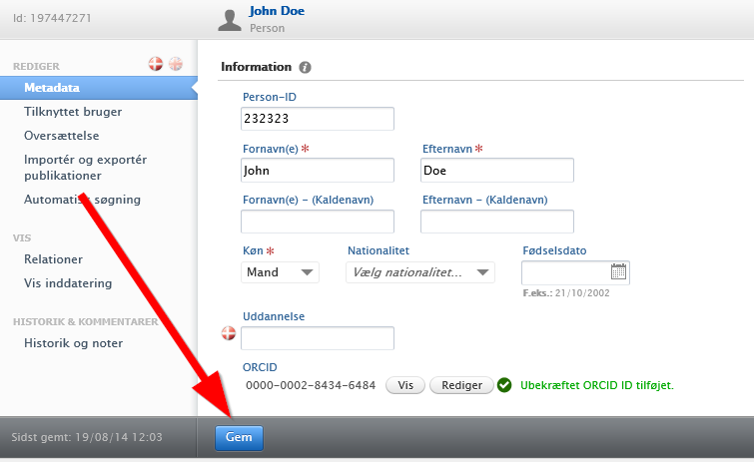

- Your ORCID ID is now linked to your Pure-profile: 